 产 品 定 作 合 同
甲方（定作方）：苏州节奏能源科技有限公司
乙方（加工方）：江苏瑞恩电气有限公司 合同编号：RE3230914-01
项目名称：美国美变项目
为保证双方的合法利益，本着平等协商、互利互惠的原则，双方依据《民法典》以及相应法规，一致同意按下列条款签订本合同。
一、产品名称、规格、型号、数量及金额 签订日期：2023年09月14日
产品名称 | 规 格 型 号 | 描述 | 单位 | 数量 | 单价  （元） | 合计  （元） | 备注
变压器 | ZGSL-H-500/ 12.47Y/7.2 /0.48Y/0.277 kv | 60Hz,YNyn0,  Loop feed,  color: telephone green(Munsell No.7.0 GY3.2/1.5) | 个 | 1 | 62110 | 62110 | 调压：±2x2.5%  45#矿物油  硅钢铁芯  全铝，阻抗6.0%，  低压套管6个孔，  空载损耗：600W  负载损耗：5410W  结构：三相3柱
变压器 | ZGSL-H-500/ 12.47Y/7.2 /0.48Y/0.277 kv | 60Hz,YNyn0,  Loop feed,  color: telephone green(Munsell No.7.0 GY3.2/1.5) | 个 | 1 | 76660 | 76660 | 调压：±2x2.5%  FR3 油  硅钢铁芯  全铝，阻抗6.0%，  低压套管6个孔，  空载损耗：600W  负载损耗：5410W  结构：三相3柱
变压器 | ZGSL-H-750/ 12.47Y/7.2 /0.48Y/0.277 kv | 60Hz,YNyn0,  Loop feed,  color: telephone green(Munsell No.7.0 GY3.2/1.5) | 个 | 2 | 96660 | 193320 | 调压：±2x2.5%  FR3 油  硅钢铁芯  全铝，阻抗6.3%，  低压套管6个孔，  空载损耗：880W  负载损耗：7150W  结构：三相3柱
变压器 | ZGSL-H-2500/ 12.47Y/7.2 /0.48Y/0.277 kv | 60Hz,YNyn0,  Loop feed,  color: telephone green(Munsell No.7.0 GY3.2/1.5) | 个 | 2 | 226660 | 453320 | 调压：±2x2.5%  45#矿物油  硅钢铁芯  全铝，阻抗6.3%，  低压套管6个孔，  空载损耗：2290W  负载损耗：21200W  结构：三相3柱
注：此价格含至上海港运费、含税(13%增值税发票)；
- 产品标识、外包装须满足出口要求且做好防潮湿处理，
- 变压器铭牌按甲方提供的铭牌模板制作，
- 变压器必须在确认图纸后才能进行生产，
- 详细技术要求见下面附件。
合计人民币总金额（大写）：柒拾捌万伍仟肆佰壹拾元整 （¥:785410.00元）
二、质量标准：按照合同后附技术协议和图纸生产，质量保证期为发货之日起18个月，不含国外售后服务费。
三、交货期限：预付款到账且合同签订生效后25天具备发货条件（遇突发事件或者不可抗拒因素除外），甲方按时提货。
四、运输及交货：在甲方厂内交货或者上海仓库，合格后出厂。
五、产品验收：甲方组织工厂验收，如对验收有异议可在发货前提出，否则视为验收合格。
六、付款方式：1、预付20%组织出图和生产，发货前付清全款。
2、甲方应将货款汇入乙方指定账户，现金结算，不得以承兑结算。
七、本合同中产品所有权自货款付清时起转移，货款未付清的，该产品所有权仍属于乙方所有。
八、本合同生效方式及违约责任：双方盖章即生效。如逾期付款每逾期一日应按照逾期金额的万分之五标准计算违约金,同时还应赔偿由此造成的全部经济损失（包括但不限于诉讼费、保全费、律师费、因保全而产生的保险费等）。若发生争议，依法向原告方所在地法院诉讼。
九、其他约定事项:
1、甲方指定的收货人： ，联系电话： ，所在单位： 。
2、每季度第1个月1-15日为乙方财务对帐日，甲方必须配合乙方财务做好往来核对。
3、本合同下的产品及包装专为甲方定制,合同生效后因任何一方的过错导致合同的解除或变更视为违约，违约方需向守约方支付合同总额20%的违约金，如合同签订日后3个月内甲方未提货，则乙方有权单方解除合同，甲方应承担违约责任及赔偿全部损失（包括但不限于诉讼费、保全费、律师费、因保全而产生的保险费等）。
4、本合同单方涂改无效，双方盖章后的传真件、电子邮件、微信图片等与原件具有同等法律效力。
5、如合同签订日当天，双方未盖章回传或预付款未到乙方账户，则本合同下定作产品价格须根据原材料价格涨幅上调；如本合同无预付款，合同签订日后45日内甲方未提货，则本合同价格及交货期须重新调整。
甲 方：  单位名称（章）：苏州节奏能源科技有限公司  单位地址：  法定代表人：  委托代理人：  电 话:  传 真：  开户银行：  税 号：  账 号： | 乙 方：  单位名称（章）：江苏瑞恩电气有限公司  单位地址：江苏·海安黄海大道西229号  法定代表人：王良明  委托代理人：  电 话：0513-88699099  传 真：0513-88837088  开户银行：中国农业银行股份有限公司海安市支行  税 号：91320600662727268A  账 号：10700101040219916

技术要求附件：
1，放油阀装在低压室内，采用此款
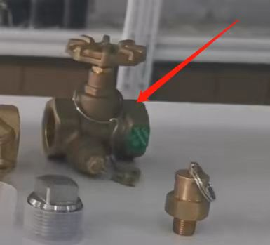
- 低压套管H0旁边加上X0，H0和X0是连接的，如接线图：
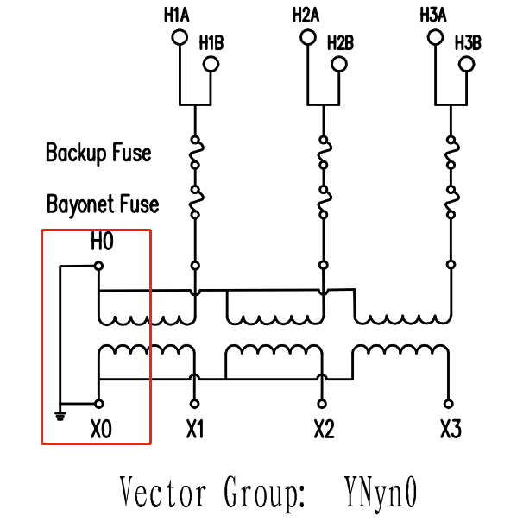

- 注油口采用直角设计，不要倾斜，采用单相美变的设计，如图：
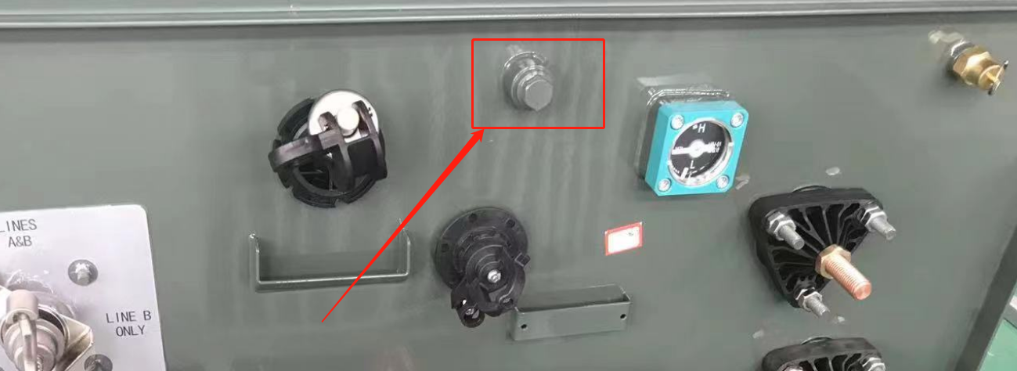

- 熔丝套管套一个集油盒，如图：
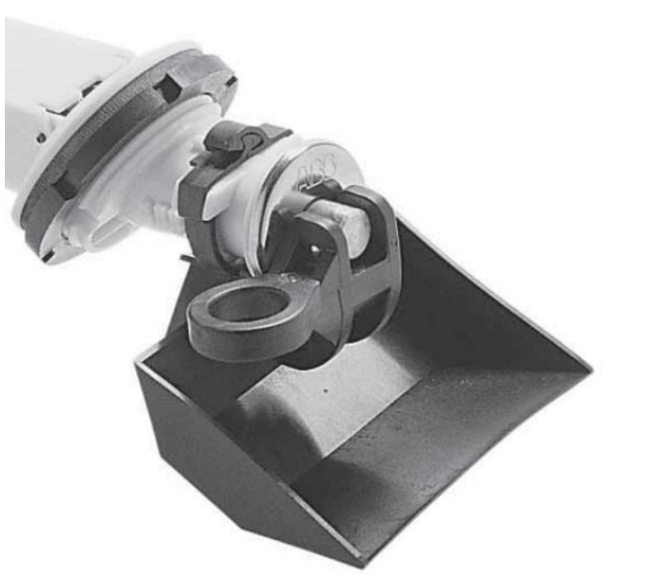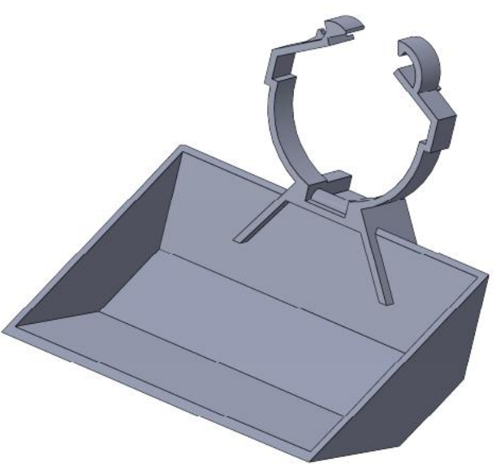

- 高低压室尺寸要完全按照美标做，前舱采用此款设计，门栓在侧面，这样门可以开成180度，如图：
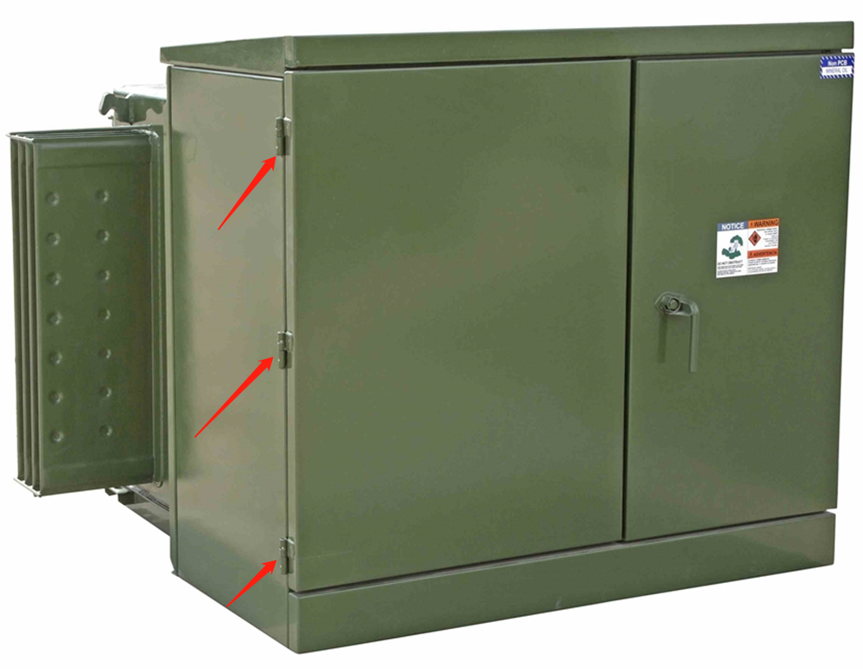

- 变压器内外都不需要任何印字，表阀标签也不要印，也不要在门上装危险提示牌，两个铭牌，一个在低压室，一个在低压室门内测。
- 门把手螺栓材质需是304不锈钢的，并且要加一个弹簧，高压套管上螺丝不能生锈，等，如图：
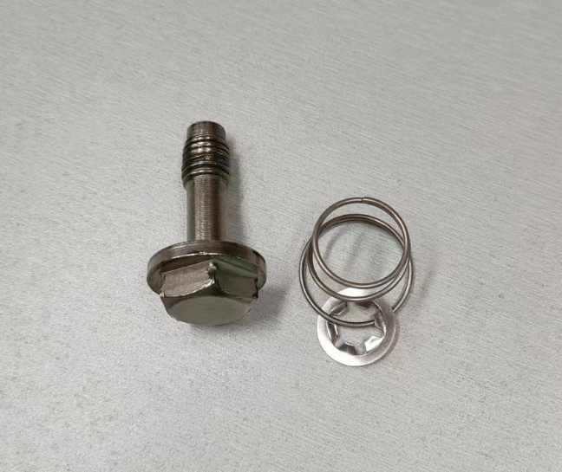

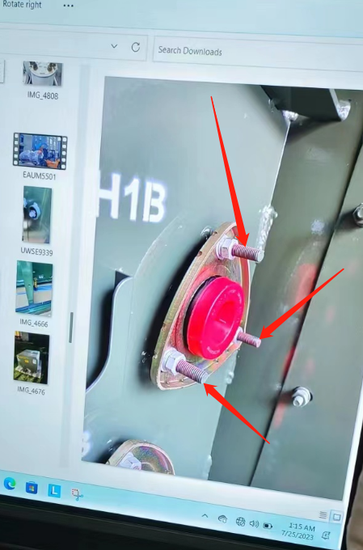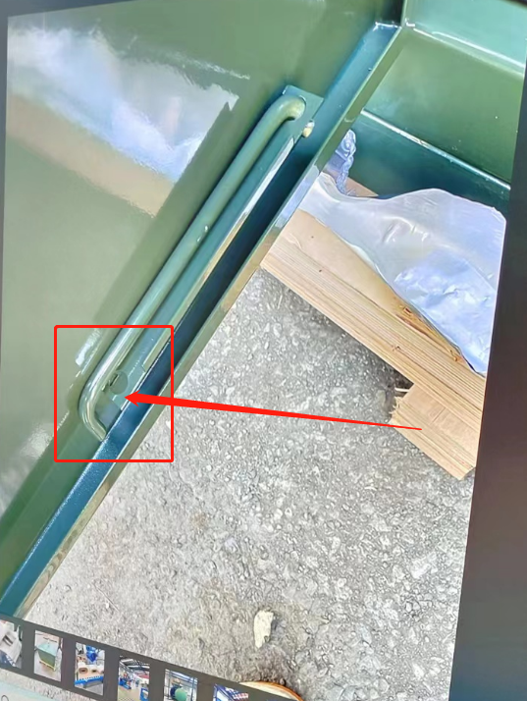
- 颜色和第一次做的30台一样，请提供色号和色卡。
- 油箱变压器室上的盖子要固定住。
- 变压器油箱和前仓需安装固定板，以便变压器可以固定安装在水泥基座上。
- 配肘型电缆接头和H0和X0连接接地的铜条。

Transformers covered by this specification shall be three-phase padmount distribution
transformers. The transformers will be used on a nominal 12kV distribution system. The
transformers will be designed to 25kV class specifications.

B. STANDARDS & TESTS
All three-phase padmount distribution transformers purchased by JIEZOU POWER shall
conform to ANSI Standard C57.12.00 (latest revision) and C57.12.26 (latest revision) with
exceptions to meet this specification. Transformers are to be factory tested per ANSI Standard
C57.12.90 (latest revision).

SPECIFICATIONS
2. The transformer nameplate shall contain a statement that the transformer contains non- PCB at the time of manufacture.
3. All transformers shall conform to Figures 2 & 3.
4. Each distribution transformer shall be equipped with a non-resettable device which
detects and provides an external indication of internal transformer faults. This device also
incorporates a pressure relief valve.
5. Transformer taps (when specified) shall be 2 - 2 1/2% below and 2 - 2 1/2% above rated
voltage. The operating mechanism of the tap changer is to be located in the high voltage
compartment. It shall be clearly marked and have a mechanism to secure the switch in its
current position to prevent accidental movement. The switch shall be secured in the
100% position at the time of shipment.
6. All transformers will be designed for loop feed with six (6) 25kV 200 amp high voltage
bushing wells mounted as per ANSI Standard C57.12.26 - Figure 6 (latest revision). They
shall be of the type that is clamped or bolted to the faceplate. This interface is to meet
ANSI Standard 386 (latest revision). All bushing wells shall have protective covers
attached to prevent contamination during shipment and storage. To meet the dimensional
requirements of Table 1, a K=5.0 is acceptable as listed in ANSI Standard C57.12.26 -
Figure 6a. Similarly, to meet the dimensional requirements of Table 1, an F=18 is
acceptable as listed in ANSI Standard C57.12.26

- Figure 7
7. Secondary terminals to be fully insulated NEMA drilled spades. They shall be of the type
that is clamped or bolted to the faceplate. Neutral terminal to be fully insulated NEMA
drilled spade. Each spade shall contain no less than six (6) holes and conform to ANSI
Standard C57.12.34 (latest revision) Figure 9b ONLY. The positioning of the secondary
terminals shall conform to ANSI Standard C57.12.34 (latest revision) Figure 8a.
8. A ground pad and a removable copper ground strap shall be provided and connected to
the neutral spade in such a way as not to subtract from the number of spade holes
available.
9. Three (3) `Bay-o-net' type fuse holders and drip pans are required on 75 - 1500 kVA
units. Fuse sizes and types as per Table 1.
10. Three (3) under oil current limiting backup fuses are required on 75-1500 kVA units. Fuse
sizes and types as per Table 1.
11. A minimum of five (5) parking stands is required.
12. A minimum of six (6) transformer tank grounding connectors required and located as per
figure 2. These shall be Blackburn TTC2 (or equivalent).
13. The transformer rating is based on a 65°C temperature rise.
14. A NEMA "DANGER - HIGH VOLTAGE" sign shall be placed on the inside of the transformer
per NEMA Standard 260, Figure 2 (latest revision).
15. Oil fill and oil drain plugs shall be located in the low voltage compartment for 75 – 750
kVA transformers. Transformers 1,000 kVA and larger shall have the oil fill plug located in
the low voltage compartment and an external drain valve with a sampling device. The
location of the drain valve and sampler shall be placed externally on the low voltage tank
side and shall be provisioned to be concealed and protected from entry by a lockable box
equipped with a recessed Penta-head bolt. The box shall be sized to sufficiently cover the
valve and removable only after the lock has been removed and the bolt loosened.
16. The liquid level gauge shall be located in the low voltage compartment of 1,000 kVA and
larger transformers.
17. The transformer enclosure shall meet the Western Underground Committee Guide No.
2.13 (latest revision).
18.The locking device on the low voltage compartment door is to consist of a captive stainless
steel Penta-head bolt
(1/2 - 13 UNC) in a non-rotating cup. It must have provision for a
padlock arranged in such a way that the lock must be removed prior to any access to the
Penta-head bolt. In addition, a second fastening device must be attached to the high
voltage compartment door. It must be arranged in such a way that the low voltage
compartment door must be opened first to allow access to the high voltage compartment
fastening device.
19. The exterior color of all transformers will be telephone green， The minimum dry paint film thickness shall be 3 mils.
20. The bottom 2" of the tank shall be treated to minimize corrosion.
21. Four (4) lifting lugs are required.
22. Transformers, 750 kVA and larger, shall have a Celsius temperature gauge located in the
low voltage compartment.
23. All transformers will be subtractive polarity.
24. Transformer impedance shall be in accordance with the table below:

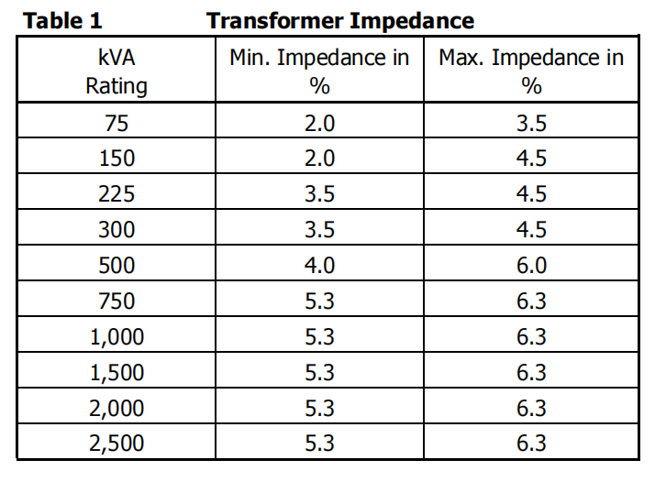

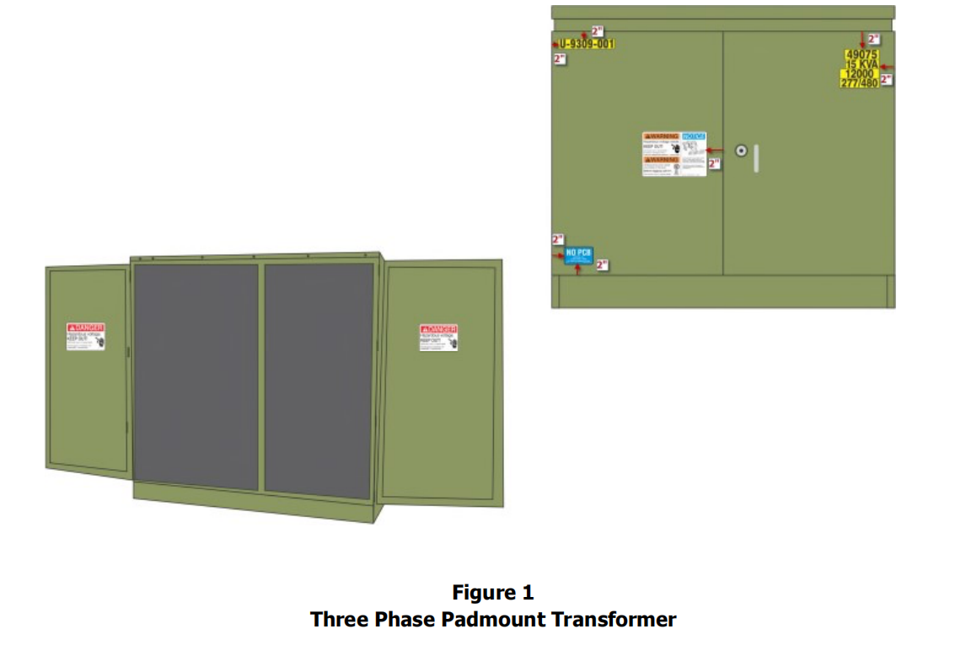
E. TEST DATA
1. All transformer Requests shall be quoted with a certified average guaranteed no-load and
total losses. Winding losses shall be calculated as total losses minus no-load losses.
2. All certified test data with additional information, as shown in Appendix A, page 12
is required on all transformer orders. This data shall be an ASCII type, commadelimited file.
The data shall be sent so that it arrives at a
minimum of one week before the arrival of the transformers.
F. G. LOSS EVALUATION
1. Losses shall be evaluated on the basis of the $/kW summarized for each load class.
2. Load classes are as follows:
a.
Residential = None.
b.
Commercial = All.
3. Each Request For Quote will contain the current $/kW factors that will be used to
evaluate them.
4. All transformers considered part of the RFB shall have efficiencies of no less than the
Department of Energy “Standard Levels For Liquid-Immersed Distribution Transformers”,
per Table I.1. of Part III of 10 CFR Part 431. Transformers not meeting these efficiency
standards will NOT be accepted by CAPE.
G. SHIPPING
1. Transformers, 75 kVA - 750 kVA, shall be shipped on a wooden pallet that allows fork
lift unloading.
H. Standards:
1. All transformer Requests shall be quoted with transformer efficiencies meeting the
Department of Energy’s “Standard Levels For Liquid-Immersed Distribution Transformers”,
per Table I.1. of Part III of 10 CFR Part 431.
2. All transformer Requests shall be quoted with a certified average guaranteed no-load
and total losses. Winding losses shall be calculated as total losses minus no load losses.
3. All transformer Requests shall have expected delivery dates of each item on the bid.
4. Outline drawings are required for each item. The drawings shall contain basic
dimensions and equipment placement.

